**SMART WASTE MANAGEMENT SYSTEM FOR METROPOLITAN CITIES**

SOLUTION FIT

**TEAM ID:PNT2022TMID26869**

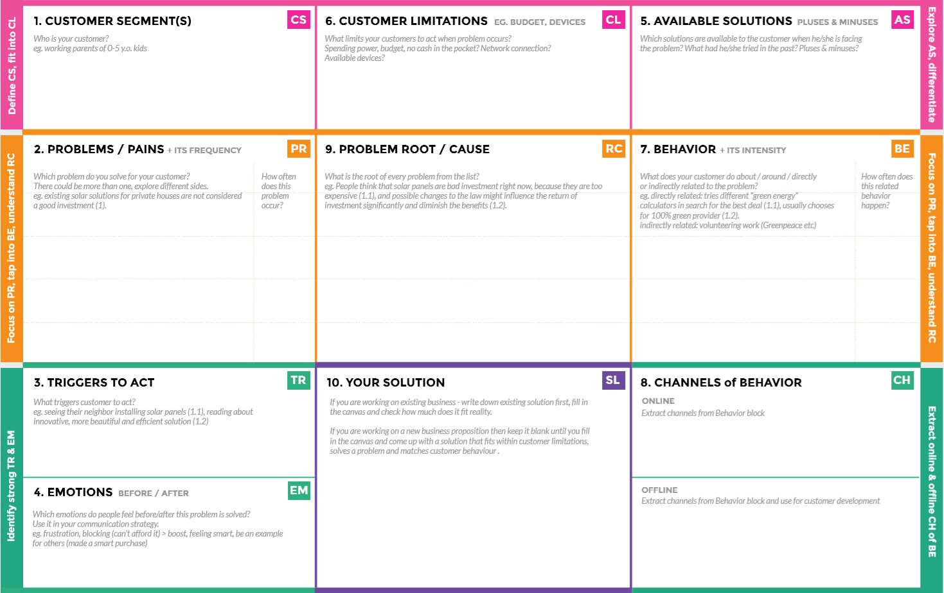

**BEFORE: tension. Low confidence ,thinking about problem and solution. AFTER: they are very happy , getting more confidence and ideas**

**Offline: Frequent food waste collection, to encourage participation.**

**Online: May be they go for advance technologies.**

***Reduce the amount of waste that is created.***

***Reuse waste material that would be disgraded.***

**Offer something to get somethingbiggerinreturn.**

1. **TRIEDOFBUGSANDINSECTS.**
2. **AIREMISSION.**
3. **SMELL**
4. **GLOBAL WARMING**

**A creative environment, Big complex garden, Place for experiment.**

**There are so many types of waste in our country like solid waste, e-waste, mediwaste etc.,**

**The government, local authorities.neighboring community, public.environmentalactivistsandmediahasbeenidentifiedasakeystakeholders**

**Recycling the nonbiodegradable wastematerial.Advanced technologies Byreusingthe product.**

**Provide better control overodor. Reducepollution.**